Lab Report: 07

Theory: The operating system must keep list of each memory location noting which are free and which are busy. Then as new jobs come into the system, the free partitions must be allocated.

These partitions may be allocated by 4 ways:
1. First-Fit Memory Allocation
2. Best-Fit Memory Allocation
3. Worst-Fit Memory Allocation

First-Fit Memory Allocation:
This method keeps the free/busy list of jobs organized by memory location, low-ordered to high-ordered memory. In this method, first job claims the first available memory with space more than or equal to it’s size. The operating system doesn’t search for appropriate partition but just allocate the job to the nearest memory partition available with sufficient size.

Code:
#include<stdio.h>
int main()
{
int p_no,b_no,b_size[10],p_size[10],b_check[10],track[10],i,j;
printf("\n Enter the number of block : ");
scanf("%d",&b_no);
for(i=0;i<b_no;i++)
{
printf("\n Enter the size of b%d : ",i+1);
scanf("%d",&b_size[i]);
}
printf("\n Enter the number of Process : ");
scanf("%d",&p_no);
for(i=0;i<p_no;i++)
{
printf("\n Enter the size of p%d : ",i+1);
scanf("%d",&p_size[i]);
}
for(i=0;i<b_no;i++)
{
b_check[i]=-1;
}
for(i=0;i<p_no;i++)
{
track[i]=-1;
}
for(i=0;i<p_no;i++)
{
for(j=0;j<b_no;j++)
{
if(b_check[j]==-1 && p_size[i]<=b_size[j])
{
b_check[j]=i;
track[i]=j;
break;
}
}
}
printf("Process_no\tp_size\tb_no\tb_size");
printf("\n\n");
for(i=0;i<p_no;i++)
{
printf(" P%d\t%d",i+1,p_size[i]);
if(track[i]==-1)
{
printf("\t Not allocated...");
}
else
printf("\tb%d\t%d",track[i]+1,b_size[track[i]]);
printf("\n");
}
}
Input and Output:
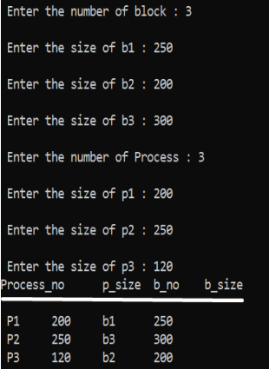

Best-Fit Memory Allocation:
This method keeps the free/busy list in order by size – smallest to largest. In this method, the operating system first searches the whole of the memory according to the size of the given job and allocates it to the closest-fitting free partition in the memory, making it able to use memory efficiently. Here the jobs are in the order from smallest job to largest job.

Code:
#include<stdio.h>
int main()
{
int p_no,b_no,b_size[10],p_size[10],b_check[10],track[10],i,j,temp;
printf("\n Enter the number of block : ");
scanf("%d",&b_no);
for(i=0;i<b_no;i++)
{
printf("\n Enter the size of b%d : ",i+1);
scanf("%d",&b_size[i]);
}
printf("\n Enter the number of Process : ");
scanf("%d",&p_no);
for(i=0;i<p_no;i++)
{
printf("\n Enter the size of p%d : ",i+1);
scanf("%d",&p_size[i]);
}
for(i=0;i<b_no;i++)
{
b_check[i]=-1;
}
for(i=0;i<p_no;i++)
{
track[i]=-1;
}
for(i=0; i<p_no; i++){
for(j=0; j<b_no; j++){
if(b_size[j] > b_size[j+1])
{
temp = b_size[j];
b_size[j]=b_size[j+1];
b_size[j+1]=temp;
}
}
}
for(i=0;i<p_no;i++)
{
for(j=0;j<b_no;j++)
{
if(b_check[j]==-1 && p_size[i]<=b_size[j])
{
b_check[j]=i;
track[i]=j;
break;
}
}
}
printf("Process_no\tp_size\tb_no\tb_size");
printf("\n\n");
for(i=0;i<p_no;i++)
{
printf(" P%d\t%d",i+1,p_size[i]);
if(track[i]==-1)
{
printf("\t Not allocated...");
}
else
printf("\tb%d\t%d",track[i]+1,b_size[track[i]]);
printf("\n");
}
}
Input and Output:
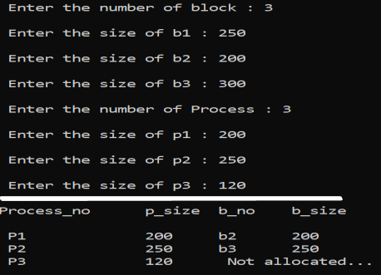

Worst-Fit Memory Allocation:
In this allocation technique, the process traverses the whole memory and always search for the largest hole/partition, and then the process is placed in that hole/partition. It is a slow process because it has to traverse the entire memory to search the largest hole.

Code:
#include<stdio.h>
int main()
{
int p_no,b_no,b_size[10],p_size[10],b_check[10],track[10],i,j,temp;
printf("\n Enter the number of block : ");
scanf("%d",&b_no);
for(i=0;i<b_no;i++)
{
printf("\n Enter the size of b%d : ",i+1);
scanf("%d",&b_size[i]);
}
printf("\n Enter the number of Process : ");
scanf("%d",&p_no);
for(i=0;i<p_no;i++)
{
printf("\n Enter the size of p%d : ",i+1);
scanf("%d",&p_size[i]);
}
for(i=0;i<b_no;i++)
{
b_check[i]=-1;
}
for(i=0;i<p_no;i++)
{
track[i]=-1;
}
for(i=0; i<p_no; i++){
for(j=0; j<b_no; j++){
if(b_size[j] < b_size[j+1])
{
temp = b_size[j];
b_size[j]=b_size[j+1];
b_size[j+1]=temp;
}
}
}
for(i=0;i<p_no;i++)
{
for(j=0;j<b_no;j++)
{
if(b_check[j]==-1 && p_size[i]<=b_size[j])
{
b_check[j]=i;
track[i]=j;
break;
}
}
}
printf("\n\n");
printf("Process_no\tp_size\tb_no\tb_size");
printf("\n\n");
for(i=0;i<p_no;i++)
{
printf(" P%d\t%d",i+1,p_size[i]);
if(track[i]==-1)
{
printf("\tNot allocated...");
}
else
printf("\tb%d\t%d",track[i]+1,b_size[track[i]]);
printf("\n");
}
}
Input and Output:
